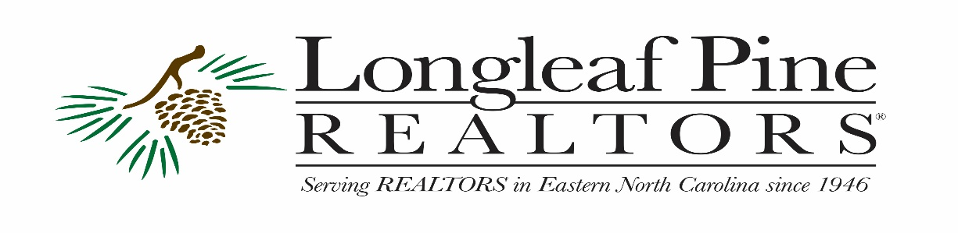
2020 Candidate Questionnaire
County Elections

Do you have any ideas or a plan to help with the current negative economic results of the pandemic and how would you implement?

Regional counties rely heavily on the presence of Fort Bragg and the reliable and steady incomes provided by salaries and government expenditures. Accordingly, construction and sales of new homes and sale of existing homes are doing well. This cannot be sustained in the long term so we must act now. The downturn of retail sales and the resulting impact on manufacturing, employment and small businesses is troubling. This in turn has put a good many of people in our community in extremis.
In my county, Hoke, we need to assist in ensuring the basic needs of residents are being met. Though a combination of Social Services, churches and other charitable organizations, we can ensure basic needs are met. The leaders of county government should encourage these resources at every turn and earn a reputation for being a caring and sharing community.
Two areas are vital to a more prosperous future of Hoke. The pandemic has given rise to a number of innovative approaches to education. It is important we “pick the cherries” of the most effective coping methods and incorporate them into future educational opportunities. Policies must be adopted that make the county known for good educational opportunities be they public, private or a combination. The other vital area is building a better environment for businesses. As business recovers from the pandemic, county leaders need to make sure we set in place programs that attract businesses to Hoke. These may include establishment of a corps of business ambassadors, aggressive advertising, a county clean-up program, and sensible zoning ordinances. Education and business are prime elements in building a better future for Hoke County.

If elected, how would you resolve any water issues (i.e. Gen X) or future water contamination in your County? How do you safe guard clean water?

Hoke County is fortunate to be supplied by deep multi-sourced well water which is available to the vast majority of residents. Water should be and is tested on a very frequent basis. Leaders should ensure employees are trained in testing and corrective measures. Potential weaknesses in the system include security for the spread pumping and storage facilities and monitoring of industrial and agricultural compliance with environmental regulations. I would ensure health department and inspection departments have adequate resources to combat deficiencies in these areas.
Health and Inspections should also widely inform private well owners of the importance of frequent testing, the parameters to be tested and the testing resources available.
I would ensure the county has in place agreements for and the ability to connect with neighboring counties’s systems so that a disaster in either county could relieve demand pressure by sharing resources.

As REALTORS® become more engaged in our communities, how do you propose to improve communication to be a part of the conversation instead of REALTORS® being reactive to issues that harm homeownership and private property rights?

Creating communication opportunities is the key to proactive responses to issues that harm home ownership and private property rights. Commissioners and Zoning Department personnel are not automatically imbued with knowledge of real estate. I would form a board to include a county commissioner, a senior county planning and zoning person, two realtors recommended by the local realty board, both commercial and residential, two builders, commercial and residential, a member of the chamber commerce, and an environmental planner. This board should meet regularly to share ideas and information and to ensure needs and plans are not on divergent courses.

This page is for LPR’s internal use, and will not be reprinted or distributed.
You can email responses to angie@longleafpinerealtors.com

Candidates Full Name:
David Frump
Candidate for Hoke County Commissioner
Daytime Phone Number:
910 690 8658

E-Mail:
davidfrump21@gmail.com

Current Occupation Position:
Retired Navy Officer
Farmer
Previously Elected/Appointed Position(s):
Treasurer, Hoke County GOP

Community Involvement:  Volunteer at Carolina Horse Park | I shared primary responsibility for location of the horse park
Community Endorsements:
Outgoing County Commissioner
Hoke County Sheriff
Chairman of Civic League
Do You Have an Active Campaign Account?
Yes
Do You Accept PAC Checks?
Yes

Thank you for taking the time to fill out our questionnaire. Questionnaire will be posted for our members to read on our website. www.longleafpinerealtors.com

Dear Candidate,

As the November elections approach, we would like for you to fill out a questionnaire for the real estate industry. Longleaf Pine REALTORS® Association has over 1,900 members regionally. Our members like to stay informed on candidates’ viewpoints and they like to go to the polls with a smart decision.

Can you take the time to fill out our questionnaire? We will post all answers on our Association website. It will also help our RPAC Committee (REALTOR® Political Action Committee) make a decision on candidate funding.

Thank you for running for office. Good luck with your campaign.

There are several ways to turn in your questionnaire.

Email: angie@longleafpinerealtors.com
Fax: 910-323-0955
Mail or drop off: 2412 Raeford Road, Fayetteville NC 28305

Sincerely,

Angie Hedgepeth
Government Affairs Director
Longleaf Pine REALTORS®, Inc.
(910) 323-1421

